Alex Arnold
Professor Torres
4-24-25
IT 120-41198
Lab 12

Part A: Wazuh

Review the videos below on Wazuh, and give your opinion on them
Review the Wazuh Proof-of-Concept guide. Choose any five (5) guides, and give your opinion.
Video 1Links to an external site.
- The content is a very good overview of the entire process from install to usage of wazuh. The only problem I have is that it presents the information very quickly and that can be hard to remember at that speed. I really like the ability to drop traffic and the idea of creating an integration with slack or even discord to notify of alerts.
Video 2Links to an external site.
-I like the speed of this video more. It is also interesting to see that he keeps the entirety of the install outputs rather than skipping to the end of the install. HE also goes into a lot more detail and has more side conversation due to the waiting for the installs. He also gives interesting advice as to how it is a good thing to learn for cyber security and why it is good to know things as a defender.
- Wazuh Proof-of-Concept GuideLinks to an external site.
- Detecting a brute-force attack
  - Rather simple instructions and assumes a base technical knowledge of the rules in the system. It would be nice to have the rules printed on the instruction page so you can see what the rules actually are instead of just the number.
- Detecting Suspicious binaries
  - Straightforward and simple instructions. I prefer the videos we watched as they added extra insights into the content.
- Blocking a known malicious actor
  - I understand the instructions but its is a bit hard to follow what they are doing. The video we watched earlier was easier to follow but then again this while this is active response it also seems to be blocking from the AlienVault list not based on activity against the server.
- Monitoring execution of malicious commands
  - Once again it is straightforward to follow the instructions but it would be nice to have a bit more explanation as to the why we are doing things rather than just the how to do them.
- Network IDS integration
  - This is a very cool and powerful integration to review network traffic. It would be nice to see this combined with he blocking known malicious actor section to implement drops based on type of traffic.

Part B: Linux Connections: Netlab 2Links to an external site., NISGTC Linux+ Series 1, lab 1
- Log on to all 4 systems
- Add the below users to all systems
  - superman, batman, Wonderwoman, theflash
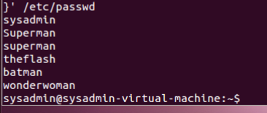
Ubuntu desktop
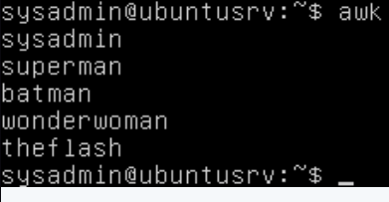
Ubuntu server
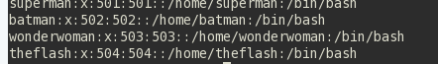
Centos
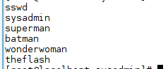
Fedora
- On the Ubuntu Workstation, log on as Superman
- From Ubuntu Workstation SSH to Ubuntu server Batman
  - from here, SSH to the CentOS server Wonderwoman
  - from here, SSH to the Fedora workstation theflash
- From Ubuntu Workstation, as theflash
  - from here, SSH to the CentOS server as Hulk
  - from here, SSH to fedora workstation as Spiderman
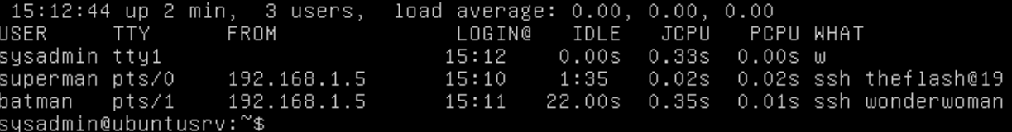
Ubuntu server connections
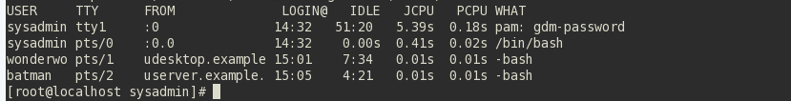
Centos connections
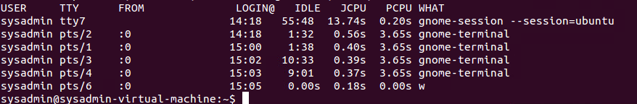
Ubuntu workstation
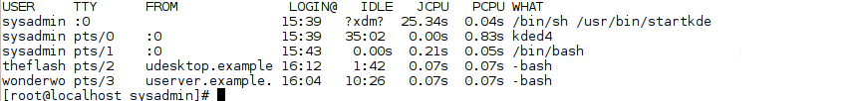
Fedora workstation
- on the Fedora Workstation
  - kill the Spiderman connection
  - show connections
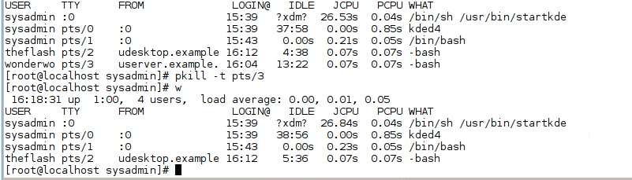
- on the centos server
  - kill the wonderwomen connection
  - show connections
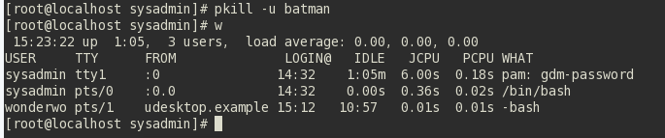
- on the Ubuntu server
  - kill the Batman connection
  - show connections
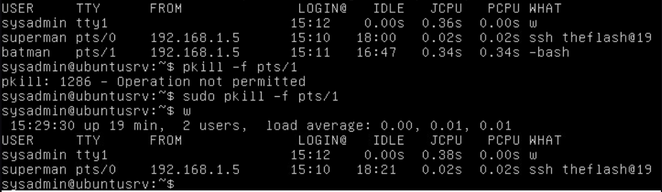
**5 points extra credit to authenticate on all systems. with public/private keys. Also known as key based authentication**

Part C: Windows Connections: Netlab 3Links to an external site., MCSA 70-740: Configure Windows Server2016
- Log on to all systems
- Add the below users to all systems
- superman, batman, Wonderwoman, theflash
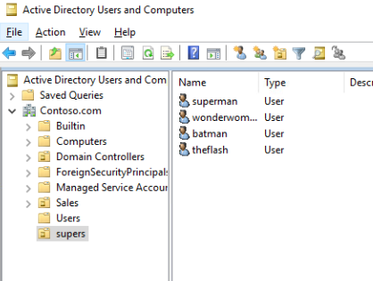
- Promote Superman and Ironman to admin on all systems
- from Win10-PCA RDP to w2k16-DCA
- from here, RDP to w2k16-DCB
- from here, RDP to Win10-PCB
- from here, RDP to Win1-PCA
- log onto all systems, and show all connections within the Task Manager
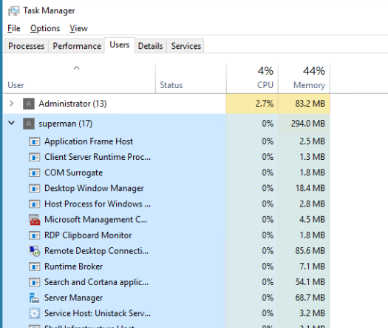
DCA
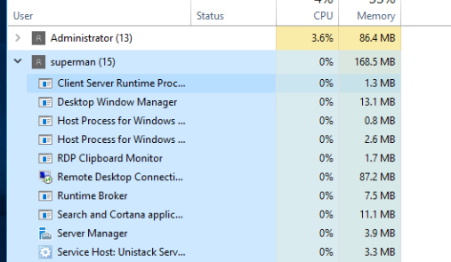
DCB
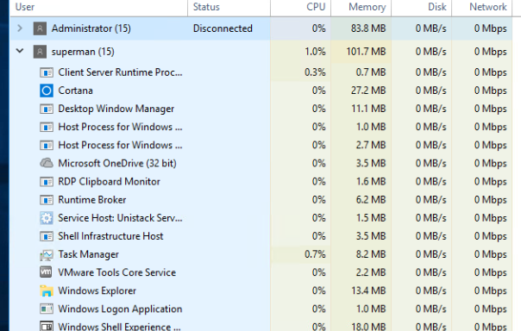
Win10-A
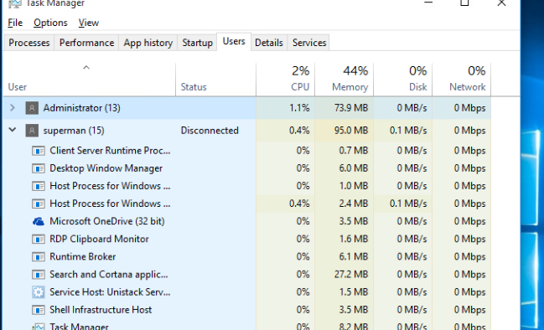
Win10-B
- Log on to Win10-PCA and disconnect the Win10-PCB connection from within the Task Manager
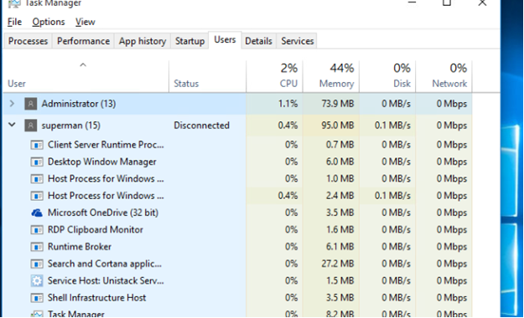
- Log onto w2k16-DCB and disconnect the w2k160DCA connection from within the Task Manager
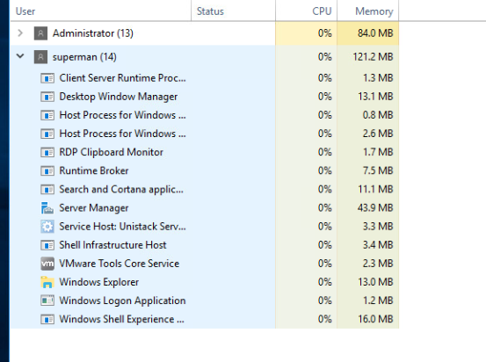
- Log onto all systems and show all of the connections via the command line or PowerShell
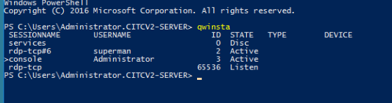
DCA
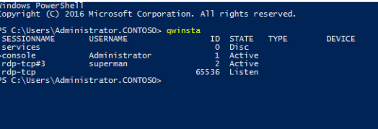
DCB
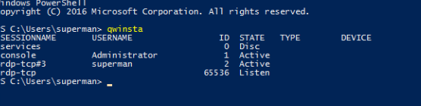
PCA
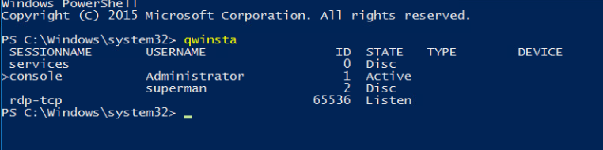
PCB
- Disconnect all connections from the Firewall on each system
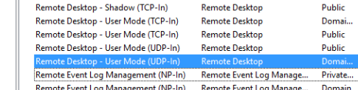
Win10-B
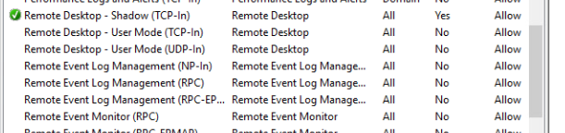
DCB
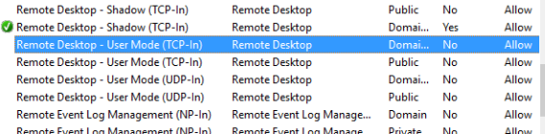
WIN10-A
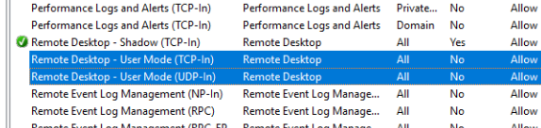
DCA

**5 points extra credit to authenticate using PowerShell, and drop users with PowerShell**

